The New Hampshire Export Promotion Program
Guidelines and Application | June 2021

Program managed and supported by 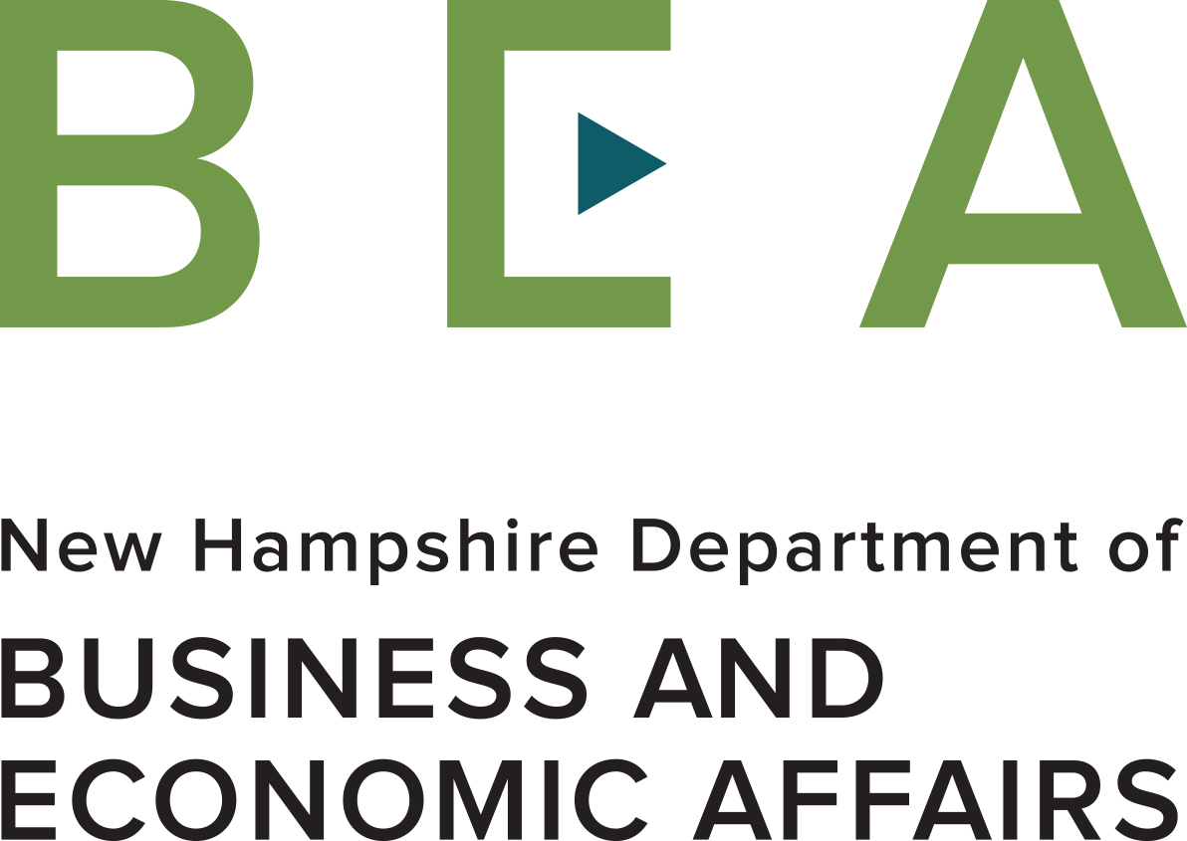 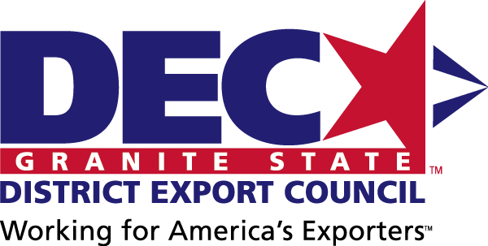

Funded in part through a grant with the U.S. Small Business Administration 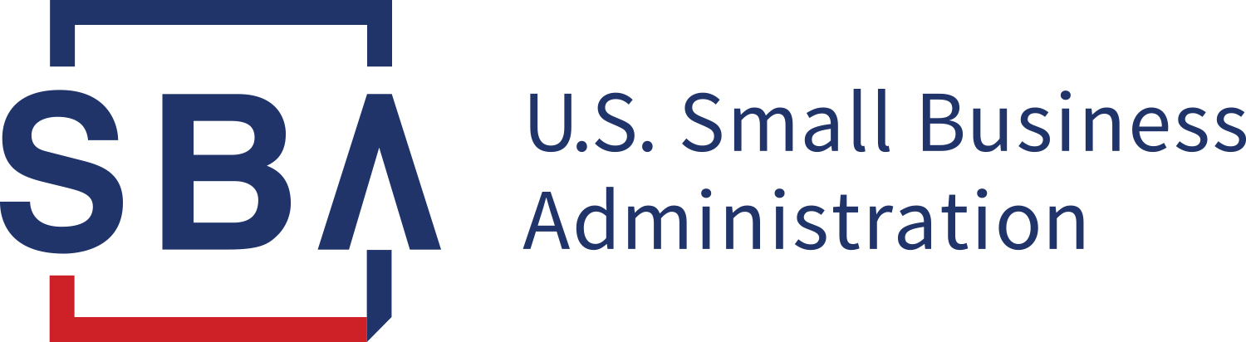

Table of Contents

 |  | Page
Section I General Information |  | 2-4
A. Program Purpose |  | 2
B. Qualification |  | 2
C. Qualifying Activities |  | 3
D. Eligible Expenses |  | 3
E. Ineligible Expenses |  | 4
Section II Filing Procedures |  | 4-5
Section III Program Reimbursement |  | 6
Section IV Review Process |  | 6
Section V Contact |  | 6

List of Attachments:

Attachment A: Export Promotion Financial Assistance Award Program Application
Attachment B: Letter of Commitment
Attachment C: Media Release Form
Attachment D: SBA Eligible Small Business Concern Form
Attachment E: SBA Form 1624, Certification Regarding Debarment
Attachment F: Export Promotion Grant Program Reimbursement Form

Section I – General Information

A. Program Updates
- New to the STEP Grant: Due to SBA modifications and requirements, all grant activities and reporting must be completed by 09/30/2022. A timeline of deliverables and deadlines are outlined in a chart located in Section II – Filing Procedures.
- Funding allowance is limited to one (1) per qualified business per grant award.
- The Program will provide 90% of the total activity cost (up to $6,000.00 per company) to qualified New Hampshire businesses to offset a portion of the qualifying expenses associated with export promotion activities. Companies are required to contribute the remaining 10% of costs

B. Program Purpose
This program is funded through a grant award from the U.S. Small Business Administration (SBA) State Trade Expansion Promotion (STEP) grant. The STEP program, which was created by Small Business Jobs Act legislation, awards grants to States to help small businesses prepare for new international markets, comply with trade regulations, access export financing, and participate in virtual international trade activities. These grants allow for each participant to prepare a customized grant application which meets your export promotion and international business objectives.

The Financial Assistance Award program, through the Office of International Commerce (OIC), is designed to enhance the capability of small to mid-sized New Hampshire companies to increase export sales. The Export Promotion Financial Assistance Award Program is a valuable tool available to qualifying companies seeking financial assistance and foreign market entry support.

The Program will provide 90% of the total activity cost (up to $6,000.00 per company) to qualified New Hampshire businesses to offset a portion of the qualifying expenses associated with export promotion activities. Companies are required to contribute the remaining 10% of costs. The proposals submitted will be ranked according to the competitiveness and innovation of the proposal. In the event funds remain following the October 9, 2020 deadline, OIC will award proposals that ranked lower and/or placed on a waiting list.

C. Qualification
Assistance is limited to New Hampshire companies that satisfy the following criteria:
- Operate a licensed business in New Hampshire to manufacture, assemble and/or distribute a product, or provide an exportable service;
- Be in good standing with the New Hampshire Department of Revenue and the IRS;
- Identify one or more specific, achievable, export initiatives requiring financial support;
- Recipients will be required to match in cash the Program award amount on a 1:1 basis and provide OIC with receipts for all qualifying expenditures associated with the activity, as noted in the “Filing Procedures” below.
- Meet the U.S. Small Business Administration’s (SBA) definition of Small and Medium-Sized Enterprise (SME). This SBA-funded program defines a SME as an entity that:
  - Complies with SBA size standards found here and referenced at 13 C.F.R. Part 121;
  - Has been in business for not less than the 1-year period ending on the date on which assistance is provided under the Program;
  - Is operating profitably, based on its operations in the US;
  - Has demonstrated understanding of the costs associated with exporting and doing business with foreign purchasers, including the costs of freight forwarding, customs brokers, packing and shipping; and,
  - Has a strategic plan for exporting in effect.
- 51% U.S. content requirement.
- Agree to be featured in articles, blogspots, social media entries, press releases and videos created by the Office of International Commerce (OIC), New Hampshire Business and Economic Affairs, and US Dept of Commerce. This includes photographic image, name and likeness and biographical material;

D. Qualifying Activities
The Export Promotion Financial Assistance Award Program is designed to provide flexibility and encourage innovative use of funds to meet the specific international needs of the New Hampshire exporter. With a focus on digital, web-based and e-commerce initiatives, this resource can support your business’s continuing international engagement virtually during the current global pandemic. Should in-person trade activities resume during the grant period and travel restrictions lifted, please consult the Office of International Commerce. Final approval for revised or new plans are subject to approval by the review panel based on status of the pandemic globally.

Qualifying activities include:
- International enhancements for your website – for example:
  - Design and development of websites with an international focus
  - Website translation into foreign language
  - NEW! Website fees to include services related to eCommerce cybersecurity
  - NEW! Mobile app integration, creation and update to support the client selling their products in international markets
  - NEW! Use of Amazon services, Walmart Marketplace, Alibaba, FlipKart, etc., for international markets
- Design of international marketing materials – for example:
  - Design of digital brochure, posters, flyers, etc.
  - NEW! Digital ad placement
  - Translation of marketing media, including audio/video
- Online export-related training and education course
- Product certification/compliance testing which impacts the ability to sell internationally (CE MARK, CSA, ISO, REACH, CITRA, etc.)
- Independent consultancy services, including creation and design of an export marketing plan; market entry strategies; cost of compliance testing (only after client consults with US Department of Commerce to avoid duplication of services)
- NEW! Costs associated with intellectual property protection
- Subscription to US Department of Commerce services (virtual or in-person)
- International trade show participation (virtual or in-person; cannot be used in conjunction with an OIC organized trade show/mission funded through STEP)
- Domestic trade show participation (must have significant international focus):
  - For example, Trade Event Partnership Program (TEPP) shows are eligible domestic trade shows for reimbursement. Contact Tina Kasim to confirm eligibility of a domestic trade show with a focus on accessing international markets.
- Foreign market sales trip (virtual or in-person)
- Overseas trade mission participation (virtual or in-person; cannot be used in conjunction with a STEP funded trade mission)
- Any other export promotion related activities, subject to approval

Note: For last year’s awardees: please be aware that any outstanding expenses associated with your STEP 8 award will not qualify as an eligible STEP 9 activity. STEP 9 activities must be separate initiatives, but may be an expansion of your STEP 8 application. Consult the Office of International Commerce with questions on what qualifies as an expansion.

E. Eligible Expenses
Qualifying Expense Categories Are Restricted to the Following:
- Virtual trade activities (sales missions, trade missions, etc) including registration costs
- Translation fees
- Website search engine optimization (SEO) and oversight and maintenance/monitoring fee for SEO
- Website localization services
- E-commerce platform (including hosting and/or maintenance fees)
- Expenses to set up websites to accept international payments.
- Digital ad placement
- Fees for compliance testing an existing product for entry into export market
- International marketing media design
- Costs relating to product certifications/compliance testing (CE MARK, CSA, ISO, REACH, CITRA, etc.)
- UPDATE! Fees associated with independent export training, certification and consulting for services that are not and cannot be offered by U.S. Commercial Service, due to high demand.
- Subscription to USDOC services (Initial Market Check, International Partner Search +, Due Diligence on Foreign Parties, etc.)
- Fees for shipping sample products
- Airfare* – Economy classes only limited to one (1) person per company. In the event two employees are needed for the activity, applicants will be required to prove the economic impact of supporting two airfares.
- Hotel ** – Accommodations only limited to one (1) person per company. In the event two employees are needed for the activities, applications will be required to prove the economic impact of supporting two hotel rooms.
- Ground transportation related directly with international travel
- Baggage fees
- Parking
- In-Person Trade Mission / Trade Show fees including but not limited to: registration fee, booth fee, equipment rental, utilities and shipments (subject to approval by review panel and changes in travel restrictions due to COVID-19)
- Currency exchange fees
- Meeting space and audio/visual costs
- Interpreter Fee
- Any other export promotion related expenses, subject to review

*If applying for reimbursement of airfare under the Program, company must comply with the federal government’s Airline Open Skies Agreements (aka Fly America Act) provisions. Federal travelers are required to use U.S. air carrier service for all air travel and cargo transportation services funded by the U.S. government. Please read through the provisions to fully understand the requirements found at: https://www.gsa.gov/policy-regulations/policy/travel-management-policy/fly-america-act.

Please note when traveling WITHIN a foreign country, a local airline carrier may be used to fly domestically/internally, should a U.S. carrier not be available. Should you not be able to abide by the Fly America Act when flying internationally, you have the option to review a waiver to check if the criteria meet your scenario. Note that you can choose to fly a foreign carrier internationally, but you cannot seek reimbursement as an eligible expense.

** If applying for reimbursement of hotel accommodations, you must comply with the U.S. State Department’s Foreign Federal Hotel Per Diem Rates. Please read the provisions to fully understanding the requirements and locate the maximum lodging rates available for reimbursement: https://aoprals.state.gov/web920/per_diem.asp. A company can only submit invoices that contain room rates, taxes and/or hotel fees. No amenities can be reflected on an invoice. This includes, but not limited to, food and beverage, internet, spa services, movies, fitness services or tourist activities.

F. Ineligible Expenses
Expense categories ineligible for reimbursement include, but are not limited to:
- Activities that occur outside of grant period of October 1, 2020 - September 29, 2022
- Printing of international marketing materials (including brochures, flyers, posters, etc.)
- Television and radio production costs
- Efforts to create or augment marketing and advertising campaigns to draw international visitors to the state.
- Airfare for classes other than Economy class
- Hotel amenities, including but not limited to, food and beverage, internet, spa services, movies, fitness activities or tourist activities
- Expenses for more than one company employee per grant activity
- Compensation, wages, or salary of any employee of the grant recipient
- Alcoholic beverages
- Meals and incidentals
- Phone and Internet usage
- Phone Cards
- Capital goods, product samples, giveaways, supplies and conference registrations
- Passport or visas fees
- Immunizations
- Expenses related to entertaining current or prospective clients or government officials
- New production development or alternation of existing products
- Equipment, cell phone or cell phone charges
- Any other ineligible expenses, subject to review

Only itemized receipts or invoices with eligible expenses will be reimbursed. No credit card statements will be accepted in lieu of itemized receipts or invoices for reimbursement.

All receipts or invoices that are not in English will need to be translated. Translations can be provided along with the receipt and currency conversion.

Section II – Filing Procedures

*New to the STEP Grant: Due to SBA modifications and requirements, all grant activities must be completed by 09/30/2022. A timeline of deliverables and deadlines are outlined in a chart below.*

- All award applications must be submitted through the Office of International Commerce (OIC) by 3:00pm EST on Friday, October 9, 2020 (attachment A).
- All applications must include a signed Letter of Commitment (attachment B)
- All applications must include a signed media release form (attachment C)
- All applications must include a signed SBA Eligible Small Business Concern form (attachment D)
- All applications must include a signed SBA Form 1624, Certification Regarding Debarment (attachment E)
- No more than one (1) application per company. If funds remain after the allocation of approved applications, companies may apply for a second round of funding.
- No less than $1,000.00 in reimbursable expenses per application.
- Reimbursements will be based on completion of activity/training and all itemized receipts compiled in one submission. No partial packages will be accepted for reimbursement.
- All reimbursements must be listed in the Reimbursement Form (attachment F). No reimbursements will be issued without attachment F.
- Financial assistance shall not exceed $6,000.00 per company as part of the export promotion program of the State of NH’s STEP grant.
    - All successful applicants must provide quarterly progress reports from October 1, 2020 – September 29, 2022. Please note once a company’s activity has concluded and the award money has been issued, progress reports are still required to be submitted for any and all remaining quarters.
- All successful applicants must provide information regarding export successes whether through joint ventures, actual sales, contract agreements, partnering with distributors/agents.

Applications are to be submitted online by 3:00pm EST on Friday, October 9, 2020 at https://nhexportassistance.com/export-promotion-grants/step-grant/. For any questions, please contact: Tina Kasim, Program Manager at tina.kasim@livefree.nh.gov.

Timetable for Deliverables and Deadlines

Deliverables | Deadlines
Application Submission | -Due by Friday, 10/9/2020 at 3 PM ET
Grant Period | - 10/1/2020 – 9/30/2022
Activity Period | -10/1/2020 – 09/30/2022  -All activities MUST be completed by 9/30/2022.
Reimbursement Requests | - All reimbursement requests MUST be completed by 10/30/2022.
Quarterly Reports | - Reports are due by the following dates:  1. 12/31/2020  2. 3/31/2021  3. 6/30/2021  4. 9/30/2021  5. 12/31/2021  6. 3/31/2022  7. 6/30/2022  8. 9/30/2022

Section III – Program Reimbursement

Recipients must complete all activities for which they have received funding within the timeframe outlined on the application. All itemized receipts associated with approved activities must be submitted to the Office of International Commerce within thirty (30) days after the event has been completed or no later than 10/30/2022. Funds are subject to availability. Applications will be reviewed and funding decisions rendered on a competitive basis.

Please note the Export Promotion Program operates on a reimbursable basis and awardees will recover authorized funds once their activity has been completed and all documentation has been received by OIC. Assistance is subject to all terms and conditions contained in the program guidelines, and application submitted.

- The New Hampshire Office of International Commerce and the U.S. Small Business Administration (SBA) will have a limited license to use data and written materials generated under this SBA grant, in line with the media policy outlined in attachment C.
- The New Hampshire Office of International Commerce has the right to cancel the application if the recipient does not adhere to stated guidelines.
- Itemized receipts are required for reimbursement of activity costs.
- Scanned copies or photo copies of the receipts will be accepted as part of the complete reimbursement package as noted in Section II.
- In the event that an award activity is not executed for any reason (i.e. change in personnel, illness, etc.) the applicant is responsible for all activity costs; no pre-paid activity costs for non-executed activities will be reimbursed by the export promotion program.
- In the event a substitution in company personnel is needed, advance notification must be sent to Tina Kasim at tina.kasim@livefree.nh.gov for approval.
- All reimbursement payments will be issued by OIC partner, the Granite State District Export Council within two-three weeks of submission.

Section IV – Review Process
All applications for funding will be evaluated by the grant program review team using the following criteria:
- Company Description (5 points)
- Project Description (35 points)
- Economic Impact (50 points)
- Project Budget (10 points)
- Only eligible applications that receive a score of 70 or higher will be approved for an award, subject to availability of funds award (100 total points possible).
- Notifications to applicants will be communicated December 2020.

OIC reserves the right to reduce the award amounts in the event that competitive grant projects exceed the total funds available.

Section V – Contact
For more information about the New Hampshire Export Promotion Grant Program, please contact the Office of International Commerce at 603-271-8444 or email:
Tina Kasim, Program Manager at tina.kasim@livefree.nh.gov

Checklist for Application:

Attachment A: Export Promotion Financial Assistance Award Program Application

Attachment B: Letter of Commitment

Attachment C: Media Release Form

Attachment D: SBA Eligible Small Business Concern Form

Attachment E: SBA Form 1624, Certification Regarding Debarment

State of New Hampshire
Department of Business and Economic Affairs **Funded in part through a grant with the U.S. Small Business Administration
Office of International Commerce
Attachment A
Export Promotion Financial Assistance Award Program Application
Activity Name: |  |  | Amount of Funds Requested:
Activity start date: |  |  | Activity end date:
Company Name:
Address: Street, Town, State, Zip Code
Contact Person & Title:
Phone:
Email:
Website:
FEIN: | NAICS Code: |  | State of Incorporation
Years in Business: | Years in Exporting: |  | International branches/offices
Employees in NH: | Employees worldwide:
Are you new-to-exporting (NTE) or expanding exports to new markets (ME)?
Provide a brief, non-technical description of the company’s products or services and application(s)
Describe the proposed international market activity (i.e. website design/translation, include names and dates of trade/sales shows/missions, etc)
What are the anticipated results and what economic impact will it have on the upon successful completion of this activity (provide information regarding projections for sales, new hires and job retention)
Have you received funding from any other source for this activity? If yes, please disclose details.

Applicants must match requested funds on a 1:1 basis and will be required to submit proof of expenses to OIC at the conclusion of the activity.
SAMPLE BUDGET
Expense Category | Estimated Cost | Reimbursable Expenses (90% of eligible expenses-not to exceed $6,000)
* Airfare (Economy class only; one company employee only) | $900 | $810
**Hotel | $2,400 (6 nights) | $2,160
Meals | $1,200 | $0 – not an eligible expense
Phone charges | $300 | $0 – not an eligible expense
Tradeshow materials shipping | $550 | $495
Ground Transportation | $250.00 | $225
Translation/Interpreter fee | $1,600 | $1,440
Trade mission/trade show | $40,000 | $36,000
Subscription to US Dept of Commerce services | $750 | $675
Independent Consultant Assistance | $0 | $0
Website internationalization | $0 | $0
International marketing material development | $3,000 | $2,700
Total | $50,950 | $44,505 of which no more than $6,000 will be reimbursed through program

ACTUAL BUDGET
Expense Category | Estimated Cost | Reimbursable Expenses (90% of eligible expenses-not to exceed $6,000)
Total | $ | $ of which no more than $6,000 will be reimbursed through program

*If applying for reimbursement of airfare under the Program, a company must comply with the federal government’s Fly America Act provisions. Please read through the provisions to fully understand the requirements found at: http://www.gsa.gov/portal/content/103191.

**If applying for reimbursement of hotel accommodations, a company must submit receipts that contain only room rates, taxes and/or hotel fees.

Information Disclosure: I certify that the information provided in this application is true and correct. I agree to abide by the STEP program funding and reporting policies. I further understand that this information will be reviewed and is pending approval. This application must be signed or it will not be considered.

By signing this application form, the applicant is agreeing to provide OIC information regarding export successes whether through joint ventures, actual sales, contract agreements, partnering with distributors/agents.

Signature of authorized company official: __________________________________________ Date: _____________________________________

Print Name: __________________________________________________

The US Small Business Administration (SBA) would like to give eligible small business concerns the opportunity to expand your knowledge and resources of other programs that are offered by the agency. Please check the appropriate box if you would like for your company’s name and contact information to be shared with other SBA programs. Your choice to participate or not, will not change the status or your participation with STEP. SBA’s aim is strictly to share information about other opportunities with you.

YES NO

Attachment B
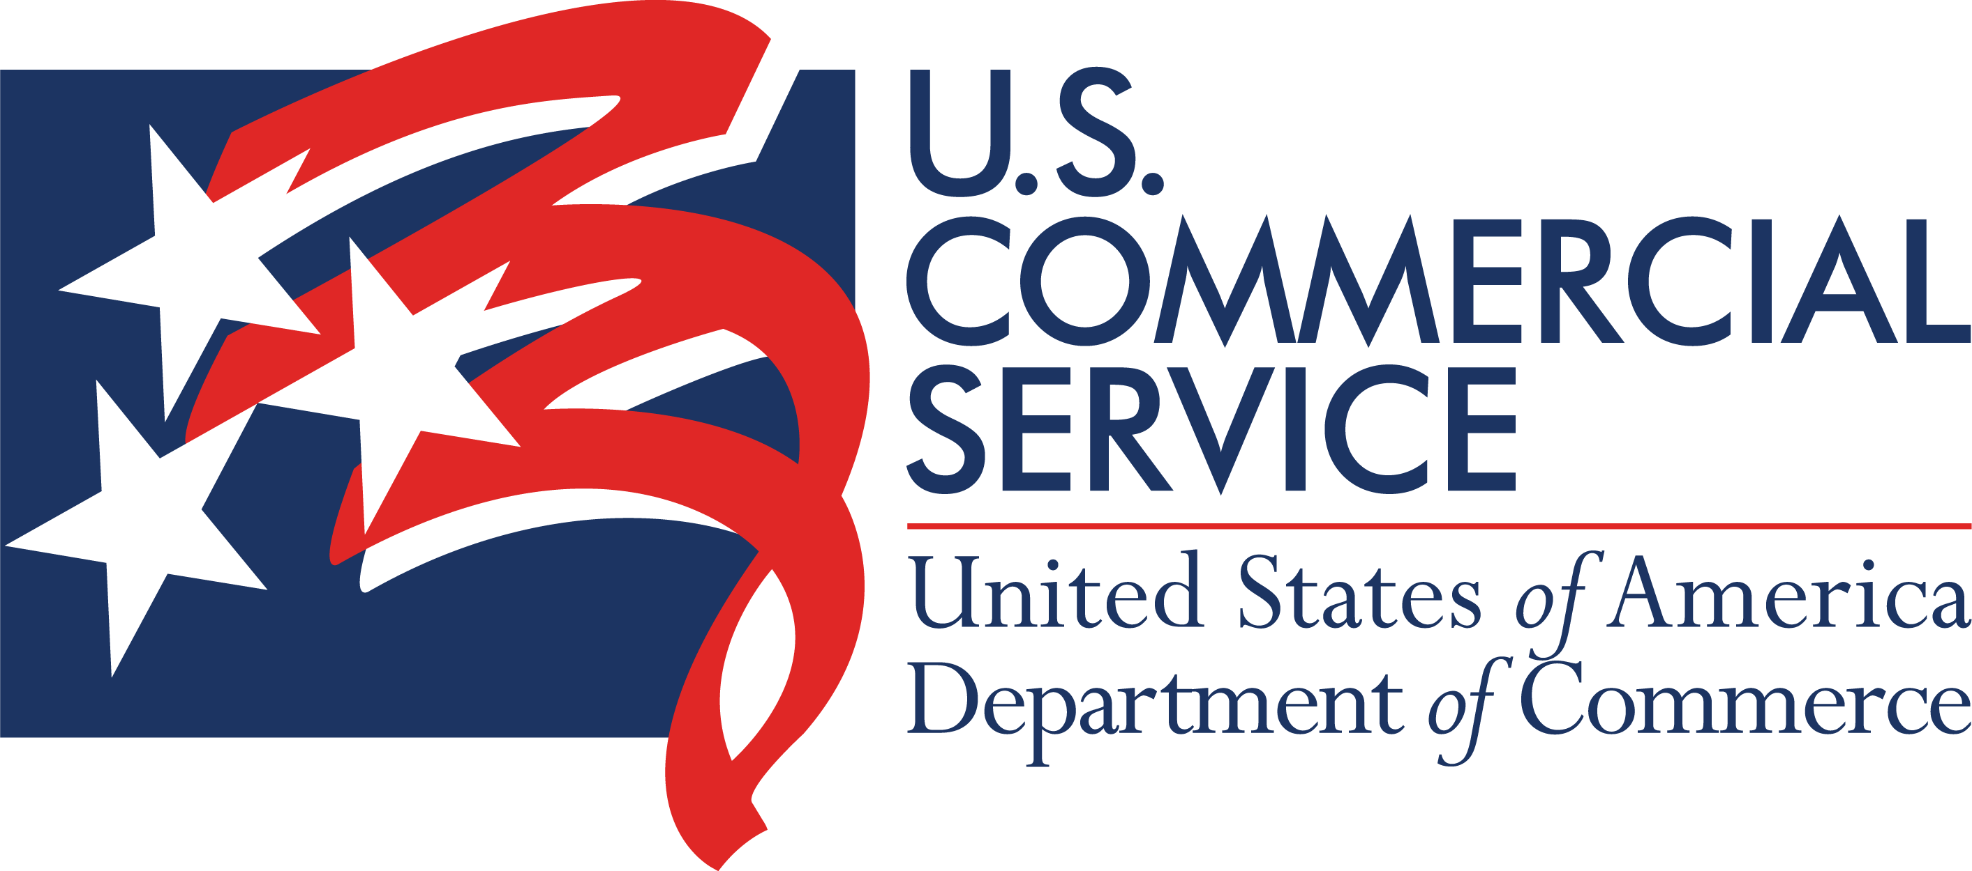

New Hampshire Export Promotion Grant Letter of Commitment

**Funded in part through a grant with the U.S. Small Business Administration

Name of Company:

I am authorized to enter into a contractual agreement for the above named company/applicant.

I have read and understand the Application Guidelines for the NH Export Promotion Financial Assistance Award Program that will be awarded by the New Hampshire Office of International Commerce (OIC).

Our company/organization certifies its ability and willingness to enter into a contractual agreement with the OIC for the NH Export Promotion Program.

Our company/organization will track all expenditures related to this project separately from other company funds, provide detailed invoices, and copies of receipts for all project-related expenses, including the company match funds

Our company/organization is able to provide 100 percent matching funds if selected as the grant recipient.

I understand that if our company is selected as a recipient of grant funds, we will receive reimbursement for authorized funds after the activity is complete and all documentation has been submitted to the OIC.

I agree to provide progress reports to the OIC detailing the progress made towards achieving the intended goals of the proposed activity. These reports will be required until the goals of the activity are completed.

I understand that the proposed project must be executed by September 29, 2022 (unless approved project is categorized differently by OIC) and that all post- activity documentation must be submitted to the OIC within 30 days of project completion, but no later than October 2, 2022, whichever date occurs sooner. I understand that reimbursement for funds will not be provided for funds spent after October 1, 2022, unless agreed upon previously with the review board (activity based) and that reimbursement is dependent upon the receipt of all project documentation within 30 days of project completion, and no later than October 30, 2022.

I certify that the information provided in this application and all supporting documents is true and correct.

I understand that any false statements made as part of this application and any supporting documents may result in substantial civil and/or criminal liability and sanctions.

Signature of Authorized Representative Title

Print/Type Signatory Name Date

Attachment C

Media Release Form

**Funded in part through a grant with the U.S. Small Business Administration

I voluntarily agree, without compensation of any kind, to allow my photographic image to appear in any print, film, digital image or videotape produced by the New Hampshire Office of International Commerce and US Commercial Service.
OIC shall have the right and may grant to others, the right to disseminate print and publish my name and likeness and biographical material in connection with the publicity and promotion of the print, film, digital or videotape related to the OIC.
I hereby release and discharge OIC and its respective agents, employees, successors, assigns and licensees from any and all claims, liabilities and obligations of any kind or nature that may arise from my appearance or participation or art work incorporated in the print, film, digital, videotape, art work or any exhibition thereof.
I agree that OIC has no obligation to exhibit or televise my performance, art work, or otherwise use my likeness, or image, in its print, film, digital or videotape.

Name___________________________________________________________________

Signature ________________________________________________________________

Address _________________________________________________________________

Attachment D
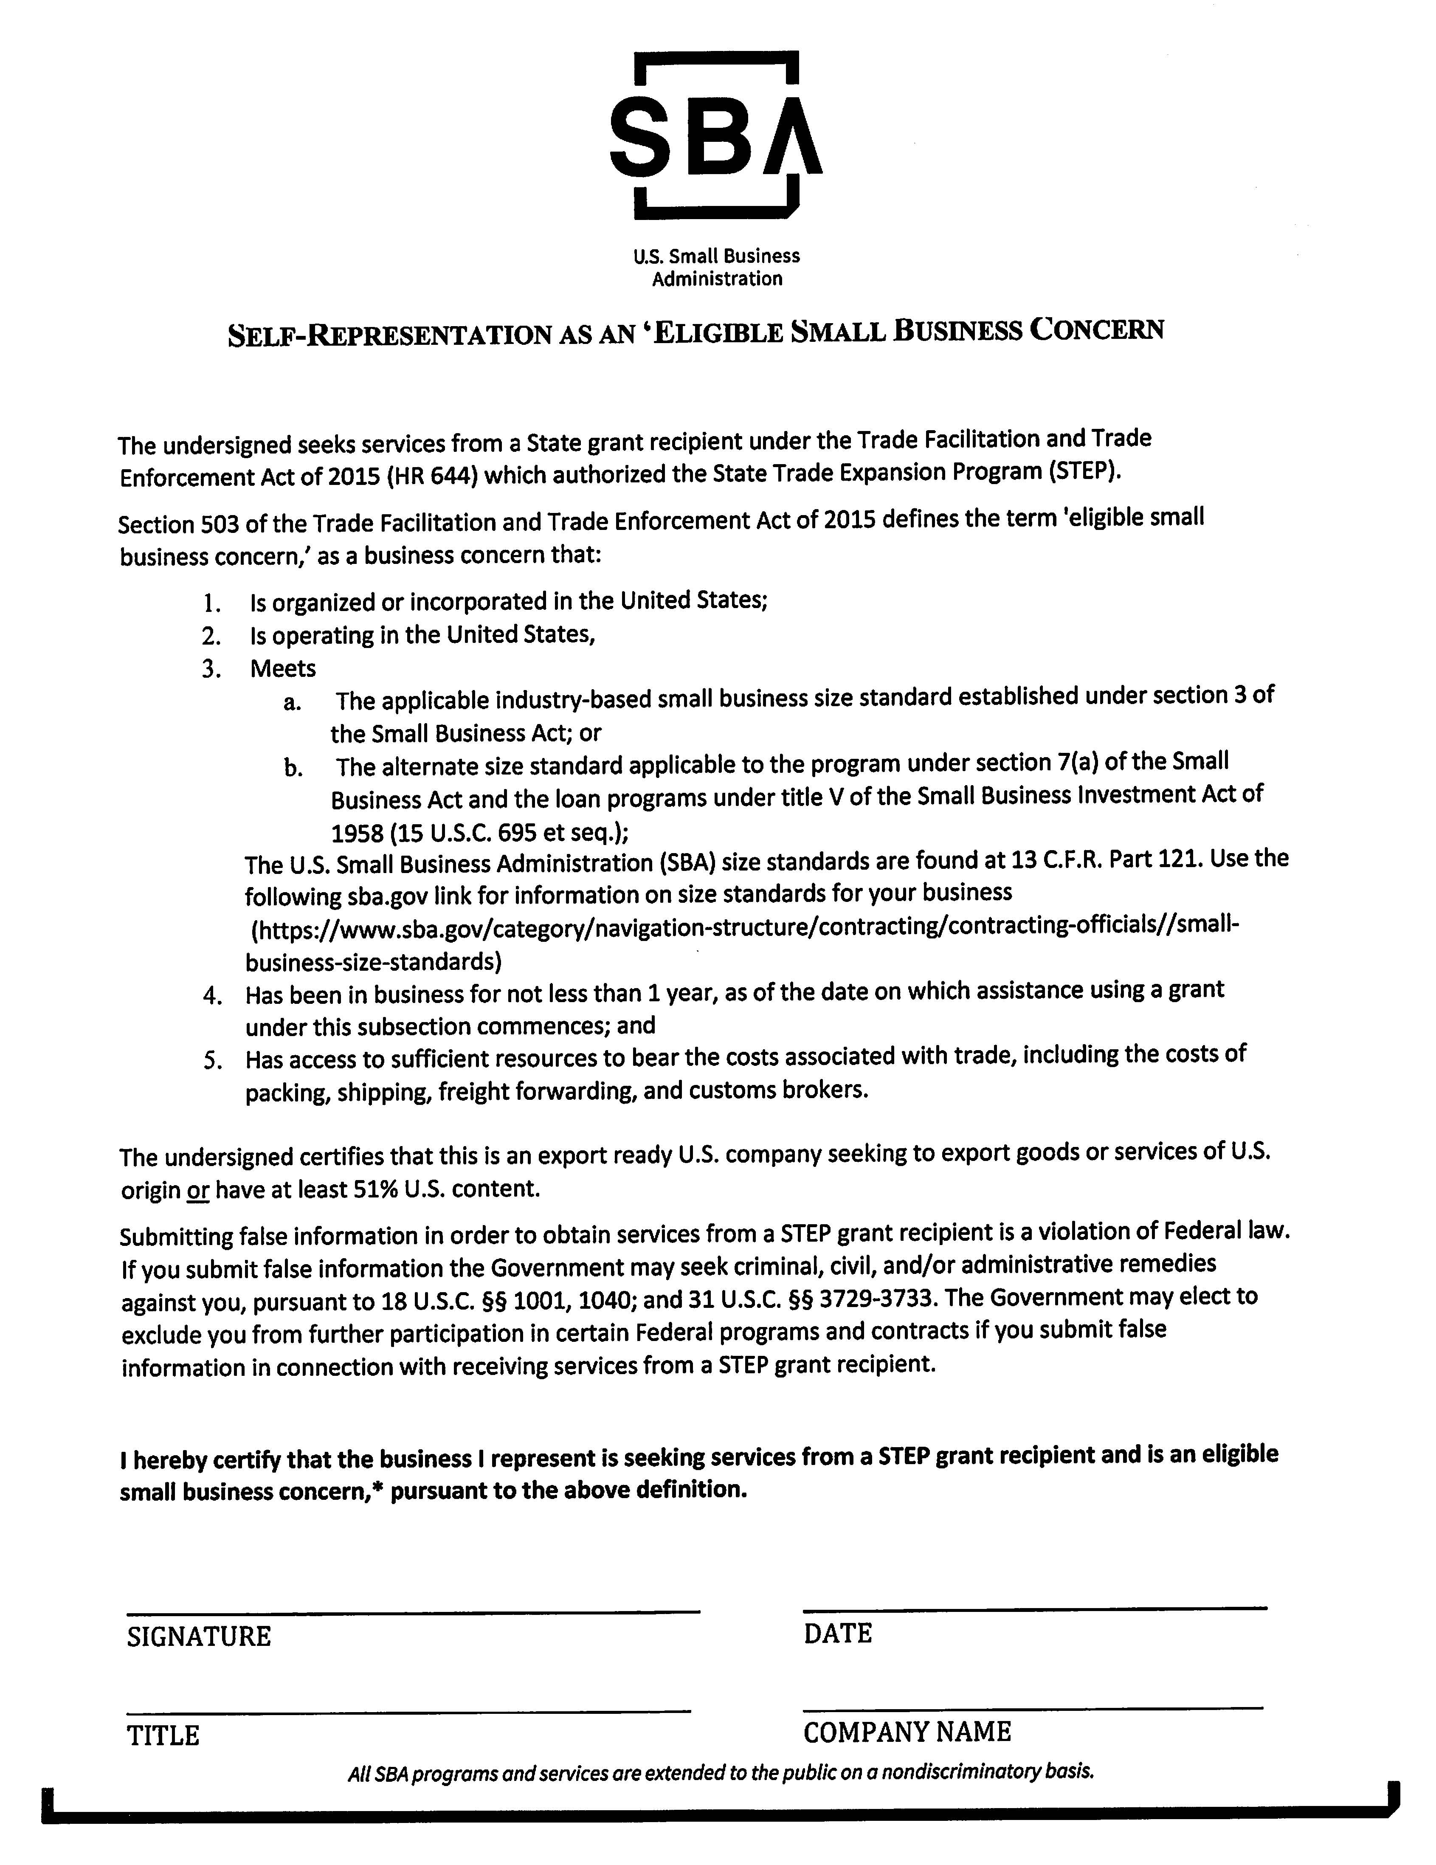

Attachment E
