The New Hampshire State Trade Expansion Program (NH-STEP)
Guidelines and Application | October 2022

Program managed and supported by 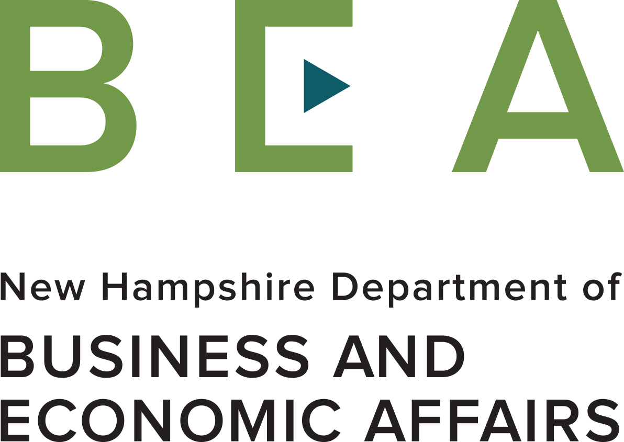 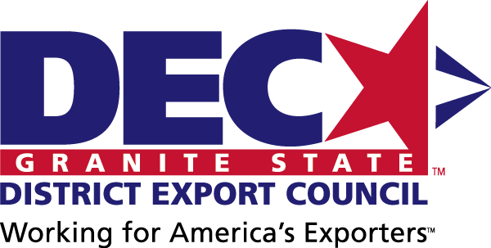

Funded in part through a grant with the U.S. Small Business Administration 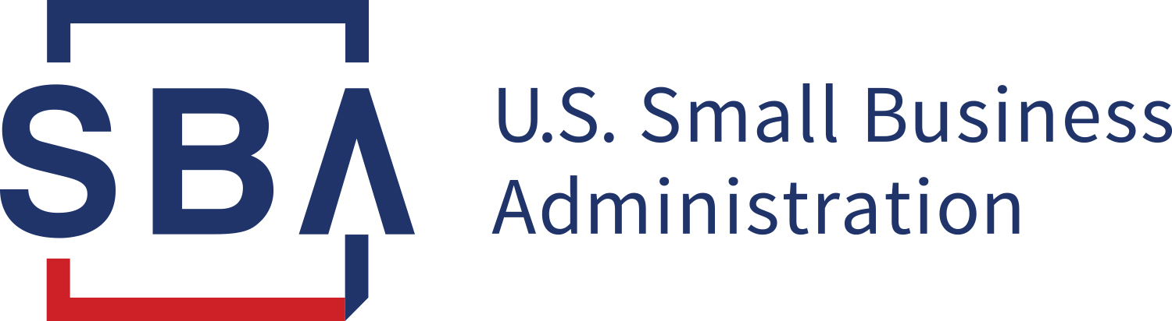

What is NH-STEP and FAA?
The New Hampshire State Trade Expansion Program (NH-STEP) provides Financial Assistance Award (FAA) grants to eligible small business concerns to promote export related activities. FAA grants range from $1,000 to $6,500 per award and provide up to 80% reimbursement for a project’s total activity cost. NH-STEP is funded in part by a grant from the U.S. Small Business Administration (SBA) and managed by the NH Office of International Commerce (OIC) with support from the Granite State District Export Council.

Does my company qualify for a FAA grant?
Assistance is limited to New Hampshire companies that qualify as “eligible small business concerns” (see http://www.sba.gov/document/support-table-size-standards), have profitable US operations, products or services for export that have at least 51% US content, are in good standing with the New Hampshire Department of Revenue and the IRS, and agree to a limited media release. An individual company that receives a FAA grant may receive a second one if funds are available.

What Expenses Qualify for Reimbursement under a FAA grant?
Qualifying Expense Categories Include:
- Export related enhancements to websites, apps or e-commerce platforms, including translation
- Department of Commerce subscription services
- Export-related training and education courses
- Design of international marketing materials, including digital materials and ad placements
- Costs relating to foreign product certifications/compliance testing
- Costs associated with international intellectual property protection
- Fees for shipping sample products
- Virtual or in-person international trade shows, foreign trade missions or foreign market sales trips
- Airfare (limited to one person, economy class on a US air carrier, and compliance with Airline Open Skies Agreements (Fly America Act) provisions)
- Hotel (limited to one person subject to U.S. State Department Foreign Federal Hotel Per Diem Rates found here. For reimbursement of hotel accommodations, submit invoices containing only room rates, taxes and/or hotel fees; amenities are not eligible for reimbursement.)
- Premiums on trade insurance (i.e. Ex-Im Bank premiums)
- Any other eligible expenses, subject to review

What Expenses Do Not Qualify for Reimbursement under a FAA grant?
Expense categories ineligible for reimbursement include, but are not limited to:
- Activities that occur outside the grant period of September 30, 2022 - September 29, 2024
- Compensation, wages, or salary of any employee of the grant recipient
- Alcoholic beverages, meals and incidentals, phone and internet usage
- Passport or visas fees; Immunizations (including Covid vaccinations and tests)
- New product development or alteration of existing products
- Printing of international marketing materials (including brochures, flyers, posters, etc.)
- Television and radio production costs
- Capital goods, product samples, giveaways, supplies and conference registrations

How Does My Company Apply for a FAA grant?
- Fill out a FAA Application providing information on your company, products or services produced, proposed international market activity, anticipated results, and project budget (Attachment A)
- Sign a Letter of Commitment outlining your company’s obligations if you receive a grant (Attachment B)
- Sign a Limited Media Release Form (Attachment C)
- Sign SBA Eligible Small Business Concern Self-Certification Form (Attachment D)
- Sign SBA Form 1624, Certification Regarding Debarment (Attachment E)
- Submit all application materials online to Alan.J.Dillingham@livefree.nh.gov with the Office of International Commerce (OIC), by 3:00 pm EDT on Friday, October 21, 2022. If funds are available, applications received after the deadline will be reviewed on a rolling basis.
- Funding decisions will be made on a competitive basis, based on the likelihood that the company’s export efforts will be sustained or expanded beyond the grant period, and the potential economic impact for the company and for job creation in New Hampshire.

How Does My Company Get Reimbursed?
- All grant activities and reporting must be completed by September 29, 2024.
- Successful applicants must provide quarterly progress reports during the entire grant period from September 30, 2022 – September 29, 2024, even after they have been reimbursed. Companies that fail to meet this requirement may not be eligible for a FAA grant in the future.
- Quarterly progress reports must provide details regarding export successes, such as joint ventures, actual sales, contract agreements, and/or partnerships with distributors/agents.
- Awardees will recover authorized funds only after their activity has been completed and all documentation and receipts are submitted in a single package to the Office of International Commerce.
- The FAA Reimbursement Form and Instructions for completing the Form can be found online at STEP FAA Reimbursement | Granite State District Council (nhexportassistance.com).
- All reimbursements must be listed on the Reimbursement Form (Attachment F). Only itemized receipts or invoices with eligible expenses and proof of payment will be reimbursed.
- If an award activity is not executed for any reason the applicant is responsible for all activity costs; no pre-paid activity costs for non-executed activities will be reimbursed.
- Reimbursement payments will normally be issued within a month of submission.

What if I have more questions?
Contact Alan Dillingham with the Office of International Commerce at (603) 271-0323 or Alan.J.Dillingham@livefree.nh.gov

