The New Hampshire State Trade Expansion Program (NH-STEP)
Guidelines and Application | October 2023

Program managed and supported by 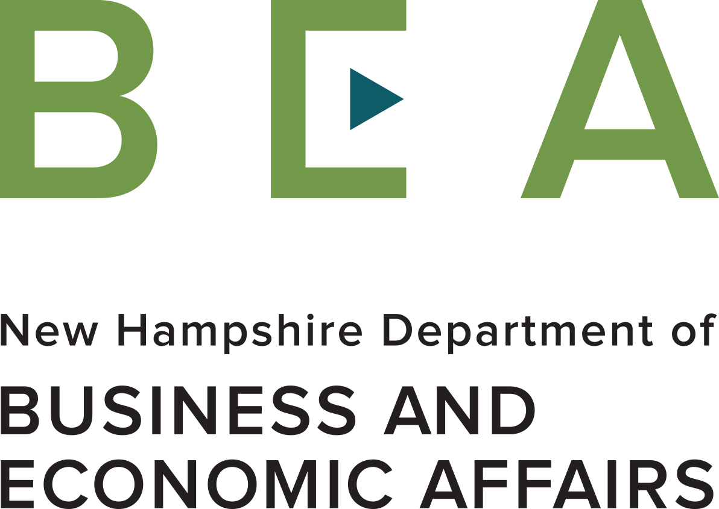 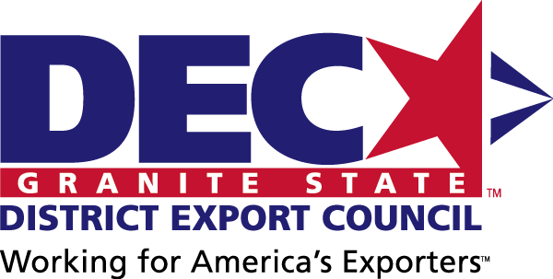

Funded in part through a grant with the U.S. Small Business Administration 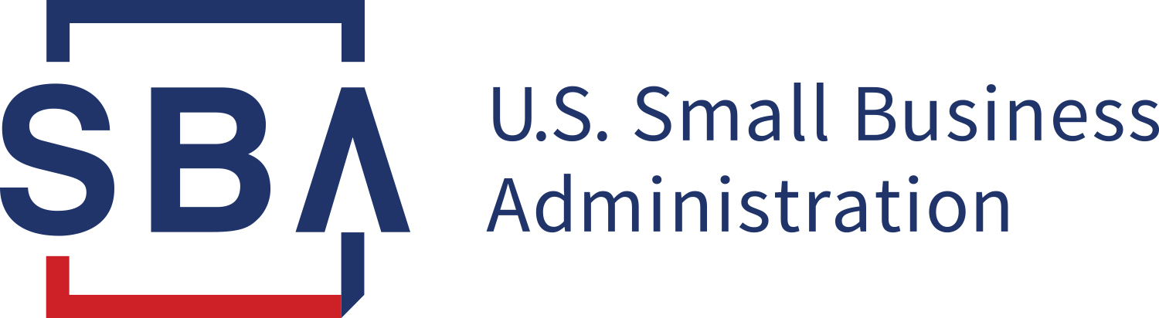

What is NH-STEP and FAA?
The New Hampshire State Trade Expansion Program (NH-STEP) provides Financial Assistance Award (FAA) grants to eligible small business concerns to promote export related activities. FAA grants range from $1,000 to $7,500 per award and provide up to 80% reimbursement for a project’s total activity cost. NH-STEP is funded in part by a grant from the U.S. Small Business Administration (SBA) and managed by the NH Office of International Commerce (OIC) with support from the Granite State District Export Council.

Does my company qualify for a FAA grant?
Assistance is limited to New Hampshire companies that qualify as “eligible small business concerns” (see www.sba.gov/document/support-table-sizes-standards), have profitable US operations, products or services for export that have at least 51% US content, are in good standing with the New Hampshire Department of Revenue and the IRS, and agree to a limited media release. Furthermore, companies must not have unused funds or unfiled reports from a previous FAA grant from NH-STEP to qualify for this round of funding. An individual company that receives a FAA grant may receive a second one, provided that the company has expended funds and been reimbursed for its first grant and if program funds are available for a second grant.

How Does My Company Apply for a FAA grant?
- Fill out and sign a Financial Assistance Award (FAA) Application providing information on your company, the product or service you wish to export, and your export project or plan. Your plan should identify the proposed international market activity you intend to fund, the anticipated results in terms of export sales and jobs created and retained, and a project budget (Attachment A)
- Sign a Letter of Commitment outlining your company’s obligations if you receive a grant (Attachment B)
- Sign a Limited Media Release Form (Attachment C)
- Sign SBA Eligible Small Business Concern Self-Certification Form (Attachment D)
- Sign SBA Form 1624, Certification Regarding Debarment (Attachment E)
- Applications that are not signed will not be forwarded to the review committee.
- Submit all application materials online to Alan.J.Dillingham@livefree.nh.gov with the Office of International Commerce (OIC), by 3:00 pm EDT on Friday, November 3, 2023. Applications received after the deadline will be reviewed on a rolling basis.

How Does My Company Win a FAA grant?
- Your application must convince a three-person review committee that you have a viable project or plan to promote export growth with the activity you propose.
- Your application must provide specific answers to the following questions:
  - What does your company do?
  - What export product or service do you wish to promote to which market(s) with this grant?
  - What is the project or plan of international market activities that you propose to fund with this grant?
  - How do you anticipate these activities will support the export growth strategy you wish to promote?
  - What results do you anticipate from these activities in terms of projected sales and job creation in New Hampshire?
- The most important part of your application is your company statement. An example is given below and, on the application, to help you prepare a statement that answers the above questions and maximizes your chances for your application to be approved.
- Example Statement on export activities supported by this grant:
  - ZEDTECH is a flexible packaging manufacturer focusing on sustainability with a specialization in liquid packaging. Our primary customers are in the personal and home care supplies sector. Our signature product is ZED pouch, a paper-based pouch for liquids that is more eco-friendly than traditional plastic pouches. ZEDTECH wants to increase its ZED Pouch exports into the Latin American market by exhibiting at the Latin Pack Chile 2024 trade show in Santiago de Chile on April 16 – 18. 2024. We anticipate the show will help us grow our relationship with existing customers and form new relationships with new customers or distributors with the goals of increasing sales and reinforcing our position as an industry leader. We conservatively estimate an increase of sales worth $150,000 from new partners in Chile and Latin America gained from this show. This will allow us to create and fill two new manufacturing positions at our facility in Berlin, New Hampshire.
- A three-person review team will score all applications using the following criteria:
  - Company Description (5 points)
  - Project Description (35 points)
  - Economic Impact (50 points)
  - Project Budget (10 points)
- Only eligible applications that receive an average score of 70 or higher (out of a possible 100 points) from the review team will be approved for an award, subject to the availability of funds.

What Expenses Qualify for Reimbursement under a FAA grant?
Qualifying Expense Categories Include:
- Export related enhancements to websites, apps or e-commerce platforms, including translation
- Department of Commerce subscription services
- Export-related training and education courses
- Design of international marketing materials, including digital materials and ad placements
- Costs relating to foreign product certifications/compliance testing
- Costs associated with international intellectual property protection
- Fees for shipping sample products
- Virtual or in-person international trade shows, foreign trade missions or foreign market sales trips
- Airfare (limited to one person, economy class on a US air carrier, and compliance with Airline Open Skies Agreements (Fly America Act) provisions)
- Hotel (limited to one person subject to US State Department Foreign Federal Hotel Per Diem Rates found here. For reimbursement of hotel accommodations submit invoices containing only room rates, taxes and/or hotel fees; amenities are not eligible for reimbursement.)
- Premiums on trade insurance (i.e. Ex-Im Bank premiums)
- Any other eligible expenses, subject to review

What Expenses Do Not Qualify for Reimbursement under a FAA grant?
Expense categories ineligible for reimbursement include, but are not limited to:
- Activities that occur outside the grant period of September 30, 2023 - September 29, 2025.
- Compensation, wages, or salary of any employee of the grant recipient
- Alcoholic beverages, meals and incidentals, phone and internet usage
- Passport or visas fees; Immunizations (including Covid vaccinations and tests)
- New product development or alteration of existing products
- Printing of international marketing materials (including brochures, flyers, posters, etc.)
- Television and radio production costs
- Capital goods, product samples, giveaways, supplies and conference registrations

How Does My Company Get Reimbursed?
- All grant activities and reporting must be completed by September 29, 2025.
- Successful applicants must provide quarterly progress reports during the entire grant period from September 30, 2023 – September 29, 2025, even after they have been reimbursed. Companies that fail to meet this requirement may not be eligible for a FAA grant in the future.
- Quarterly progress reports must provide details regarding export successes, such as joint ventures, actual sales, contract agreements, and/or partnerships with distributors/agents.
- Awardees will recover authorized funds only after their activity has been completed and all documentation and receipts are submitted in a single package to the Office of International Commerce.
- The FAA Reimbursement Form and Instructions for completing the Form can be found online at STEP FAA Reimbursement | Granite State District Council (nhexportassistance.com). (Please note that as of October 2023, this web page is under construction.)
- All reimbursements must be listed on the Reimbursement Form, provided by the NH Office of International Commerce. Only itemized receipts, or invoices with eligible expenses and proof of payment, will be reimbursed.
- If an award activity is not executed for any reason the applicant is responsible for all activity costs; no pre-paid activity costs for non-executed activities will be reimbursed.
- Reimbursement payments will normally be issued within a month of submission.

What if I have more questions?
Contact Alan Dillingham with the Office of International Commerce at (603) 271-0323 or Alan.J.Dillingham@livefree.nh.gov

